**Ideation Phase**

**Define the Problem Statements**

|  |  |
| --- | --- |
| Date | 26 June 2025 |
| Team ID | LTVIP2025TMID49346 |
| Project Name | Cosmetic Insights |
| Maximum Marks | 2 Marks |

**Customer Problem Statement Template:**

Create a problem statement to understand your customer's point of view. The Customer Problem Statement template helps you focus on what matters to create experiences people will love.

A well-articulated customer problem statement allows you and your team to find the ideal solution for the challenges your customers face. Throughout the process, you’ll also be able to empathize with your customers, which helps you better understand how they perceive your product or service.

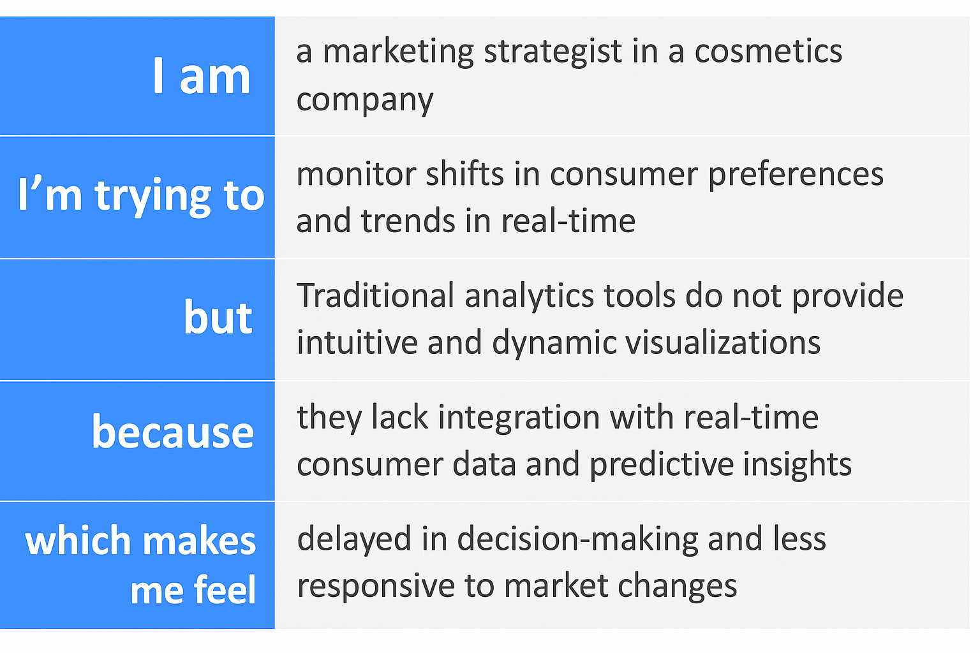

Reference: <https://miro.com/templates/customer-problem-statement/>

**Example:**

|  |  |  |  |  |  |
| --- | --- | --- | --- | --- | --- |
| **Problem Statement (PS)** | **I am (Customer)** | **I’m trying to** | **But** | **Because** | **Which makes me feel** |
| PS-1 | a marketing strategist in a cosmetics company | monitor shifts in consumer preferences and trends in real-time | traditional analytics tools do not provide intuitive and dynamic visualizations | they lack integration with real-time consumer data and predictive insights | delayed in decision-making and less responsive to market changes |
| PS-2 | a quality assurance manager in the cosmetics industry | identify and respond quickly to negative reviews or product safety issues | it's challenging to track and analyze concerns across multiple data sources | existing systems do not provide centralized real-time access to product feedback | worried about brand trust and unable to act proactively |